Task – 1: Deploying a web app with Hello World docker image
Step 1: Filling in the basic details for the web app, this screen is accessed by search for app services and selecting web app in create menu.
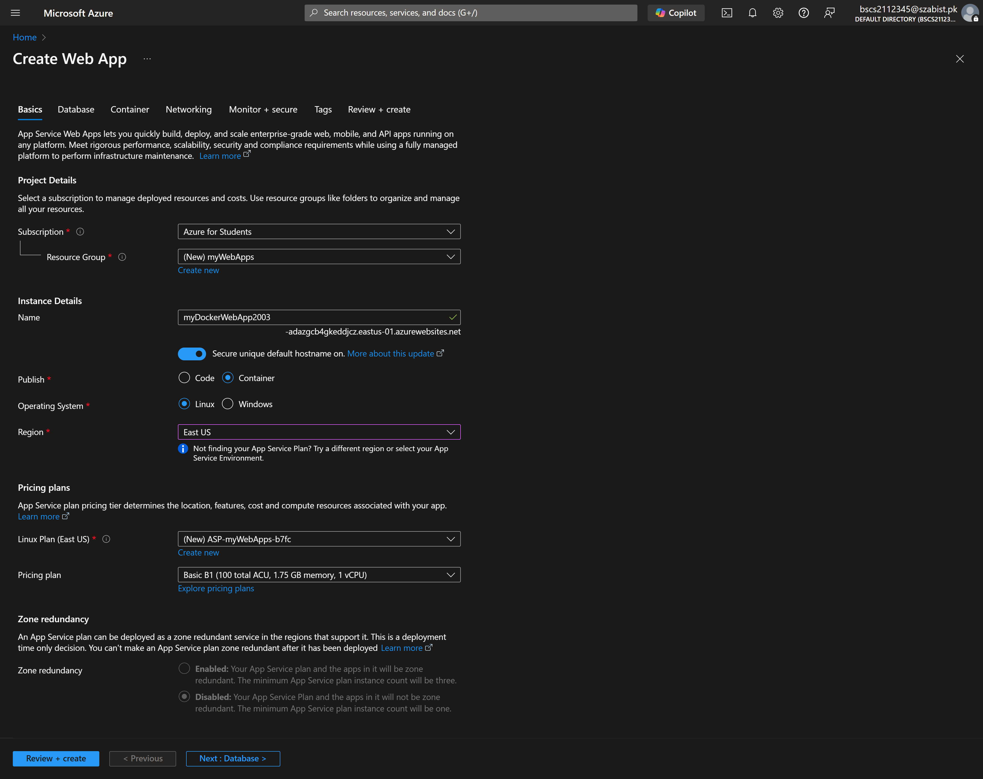
Step 2: Specifying the docker image to be used to create the container
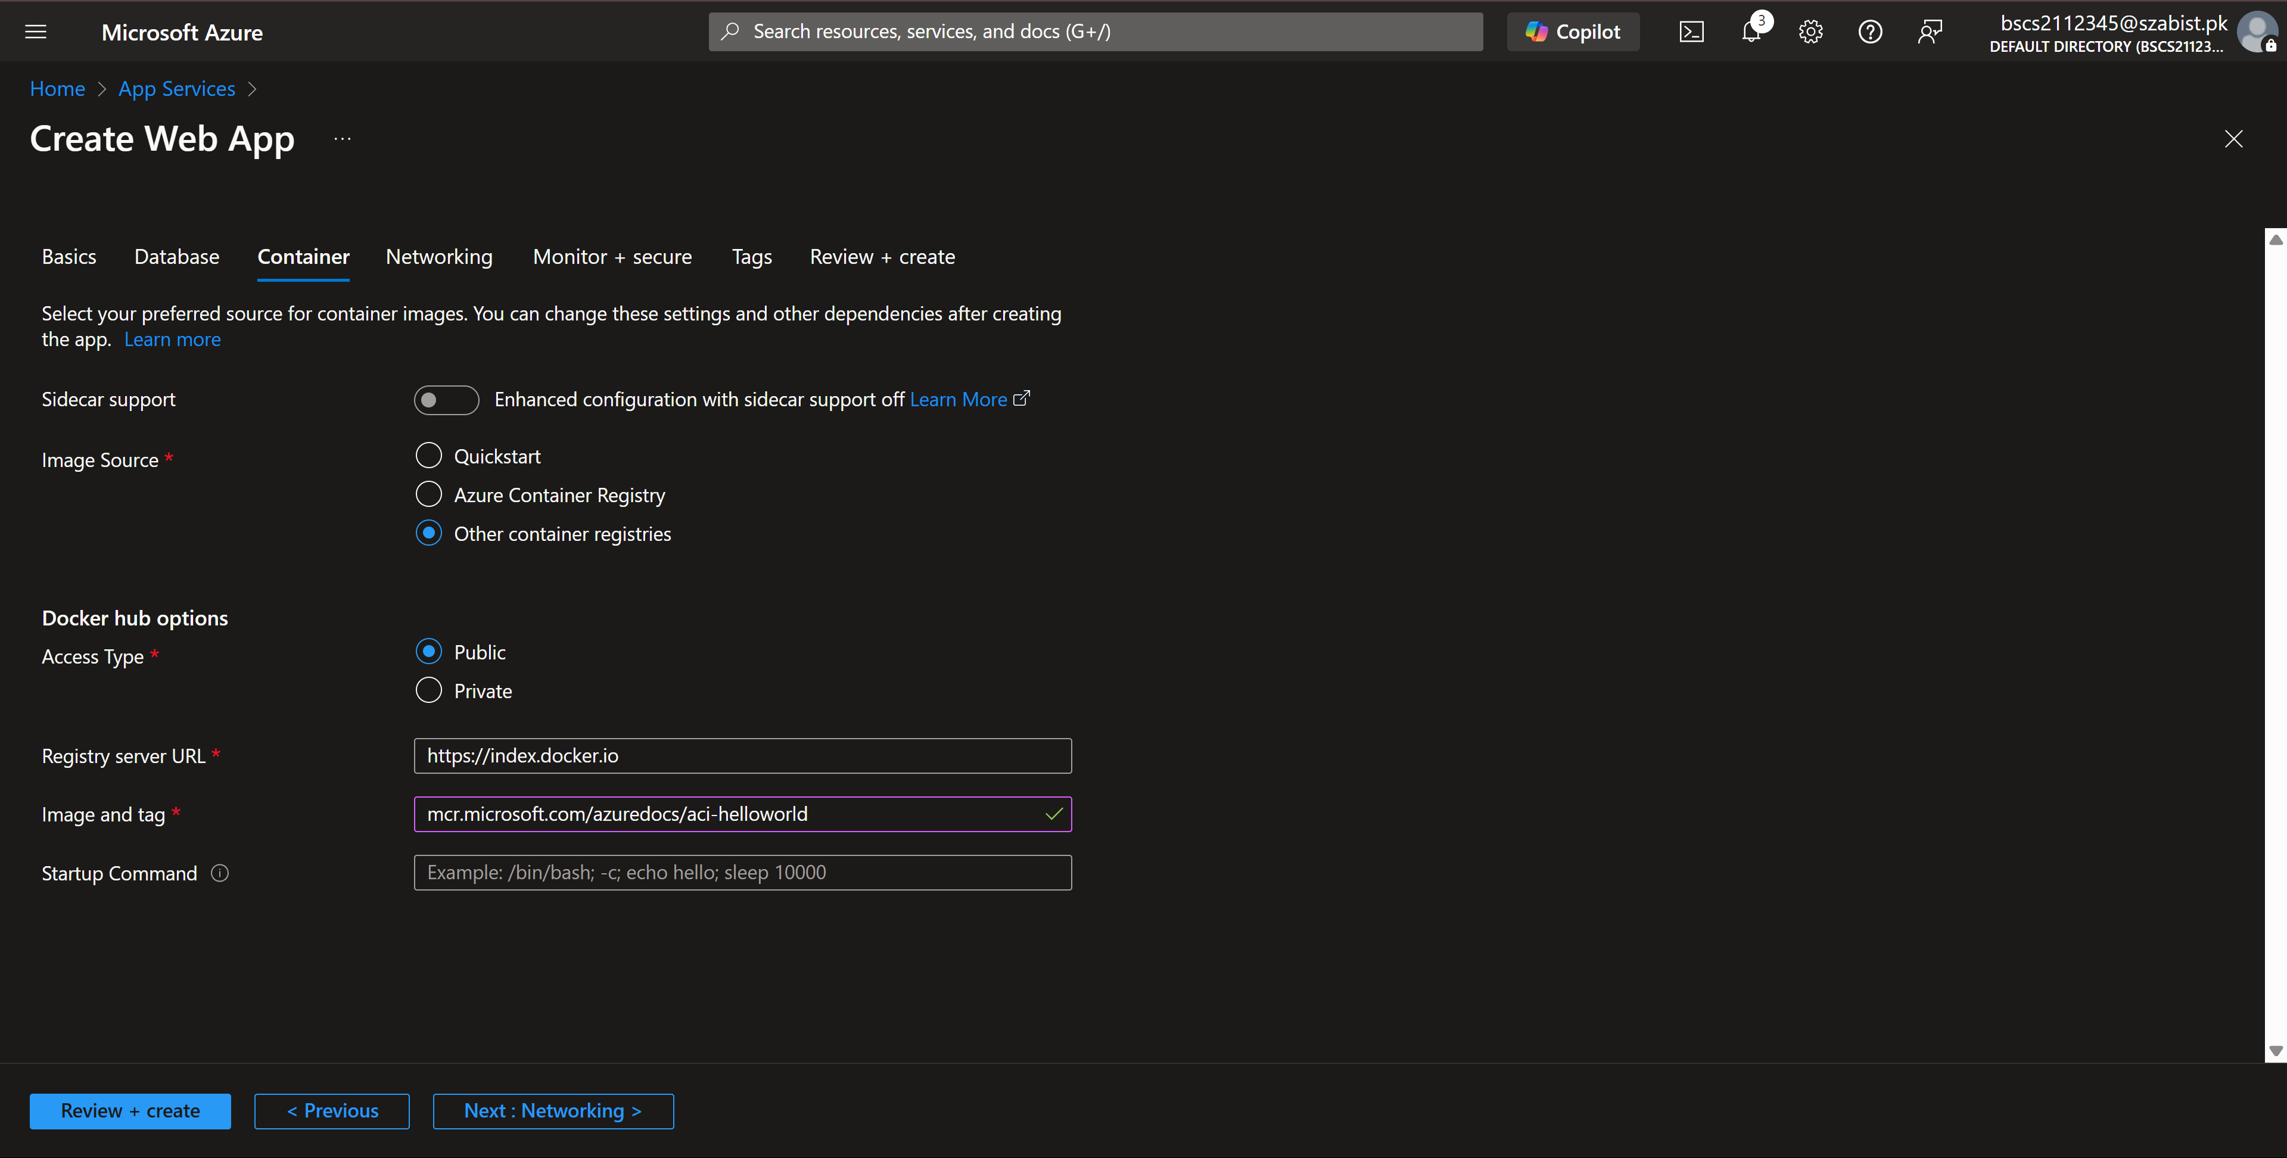

Step 3: Displaying the complete configuration of the web app with the validation tests passed.
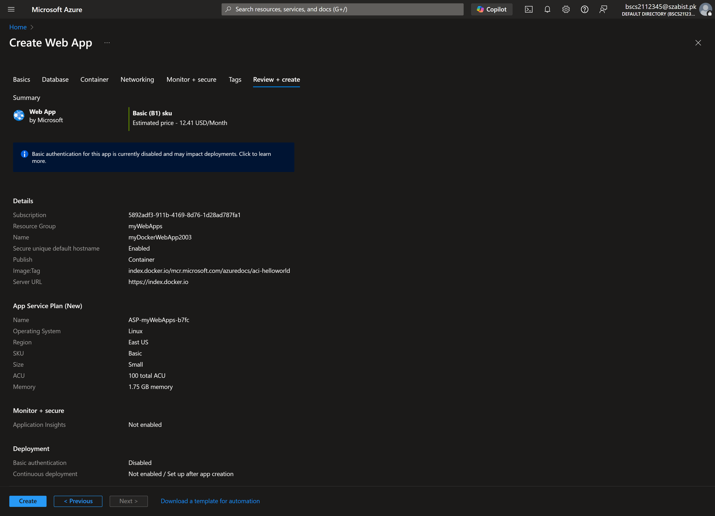

Step 4: Accessing resource after it’s successful deployment/creation, we can see the basic information in the overview tab for the webapp.
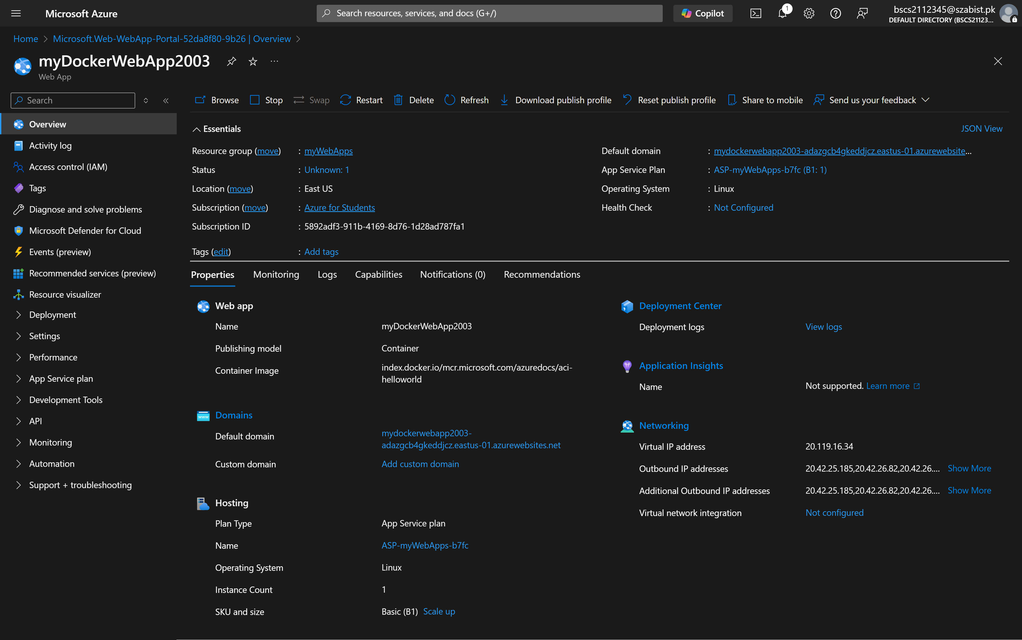
Step 5: Accessing the web app through the public IP address.
